Chapter 1
Introduction
 | Deepfake technology has rapidly evolved, posing serious threats to misinformation, fraud, and cybersecurity. Malicious actors use deepfakes to manipulate public opinion, spread false narratives, and damage reputations. Traditional detection methods struggle to keep up with increasingly sophisticated AI-generated content. Our project focuses on developing a robust and efficient deepfake detection system using advanced machine learning techniques. By ensuring accurate and timely identification of deepfakes, we aim to enhance digital security and prevent the spread of misinformation.
1.1 | Problem Statement
 | The rapid advancement of deepfake technology has made it increasingly difficult to distinguish between real and manipulated media, posing serious threats to misinformation, public trust, and digital security. Traditional detection methods struggle to keep up with the evolving sophistication of AI-generated deepfakes, making them less effective in identifying fraudulent content. The project aims to develop an AI/ML-powered deepfake detection system that enhances accuracy, efficiency, and scalability in identifying manipulated media.
1.2 | Objectives of the Project
The objectives of the project are:
- Develop an advanced deepfake detection system using state-of-the-art models for video analysis .
- Ensure accurate and reliable identification of deepfake content, providing clear and easy-to-understand authenticity assessments.
- Create a user-friendly platform with intuitive features such as file upload widgets for seamless interaction.
- Enhance accessibility and usability by delivering actionable insights and transparent results to help users make informed decisions.
1.3 | Scope of the Project
The project focuses on the following aspects:
•Utilizes advanced AI models for video to enhance accuracy and reliability.
•Develop an interactive, easy-to-use interface with real-time or near-real-time detection capabilities, making deepfake analysis accessible for various applications, including media verification and cybersecurity.
1.4 | Relevance/Significance of the Project
 | This project is crucial in combating misinformation, enhancing digital security, and preserving media integrity by accurately detecting deepfake content. Leveraging advanced AI models to ensure robust detection against evolving threats. The user-friendly platform enables real-time or near-real-time analysis, making deepfake detection accessible and scalable for various applications.

Chapter 2
Literature Survey
2.1 | Review of Existing Systems/ Related Work

1. Face Warping Artifacts
- Approach: The method detects artifacts by comparing generated face areas with their surrounding regions using a dedicated Convolutional Neural Network (CNN) model.
- Key Observations: Deepfake algorithms can only generate images at limited resolutions, requiring further transformations to match faces in the source video.
- Limitation: The method does not consider temporal analysis of the video frames. It focuses only on spatial discrepancies, which can be limiting as some subtle temporal features may be missed.

2. Detection by Eye Blinking
- Approach: The method focuses on eye blinking as a crucial parameter for distinguishing between deepfake and authentic videos. The temporal analysis of cropped eye-blinking frames was conducted using Long-term Recurrent Convolution Network (LRCN).
- Key Observations: Eye blinking inconsistencies can be a strong indicator of deepfakes, but modern deepfake generation algorithms have become sophisticated, often making the absence of eye blinking less noticeable.
- Limitation: Eye blinking alone is insufficient for detection. Other indicators like teeth enhancement, wrinkles, or incorrect placement of eyebrows should also be considered for more robust deepfake detection.

3. Capsule Networks to Detect Forged Images and Videos
- Approach: This work uses Capsule Networks to detect forged images and videos, particularly for replay attack detection and computer-generated video detection.
- Key Observations: Capsule Networks are used to capture complex spatial relationships in images, potentially improving detection of manipulated media.
- Limitation: The method incorporates random noise during training, which can affect the model’s robustness. While the model performed well on their specific dataset, it may not generalize effectively to real-time data due to the noise introduced during training.
- Innovation: The idea of capsule networks for detecting visual forgeries is innovative, but it requires more stable and realistic training data to improve real-world performance.

2.2 | Comparative analysis of Existing Systems
Study | Approach | Strengths | Weaknesses
Face Warping Artifacts | CNN-based spatial artifact detection | Detects visual inconsistencies in the face region due to resolution limitations in deepfake generation. | Does not consider temporal analysis of video frames, which could miss subtle temporal features.
Detection by Eye Blinking | Eye blinking detection with LRCN for temporal analysis | Eye blinking inconsistencies are a strong indicator of deepfakes. | Eye blinking alone is insufficient for robust detection; additional indicators like wrinkles, eyebrows are needed.
Capsule Networks for Forged Images | Capsule Networks for spatial relationship detection in media. | Captures complex spatial relationships, enhancing detection of manipulated media. | Training with random noise may reduce robustness in real-time applications; requires stable training data.
The comparative analysis highlights spatial methods focusing on visual inconsistencies, while temporal methods address dynamic changes in videos. Both approaches need enhancement with additional indicators and larger datasets for better real-time performance.

2.3 | Gaps Identified
- Complex User Interface: The proposed system focuses on a simple, user-friendly interface to make deepfake detection easy and accessible for all users.
- Lack of Confidence Feedback: The proposed system displays model confidence alongside detection results, allowing users to assess the reliability of the predictions.
- No Real-Time Video Feedback: The proposed system shows the real-time video with live face detection and confidence scores, improving user interaction and trust in the results.
- Limited Platform Compatibility: The proposed system is cross-platform compatible and can run on any device with a web browser, expanding accessibility and user reach.

2.4 | Proposed System
 | A robust deepfake detection system is developed using ResNet for video analysis, LSTM for temporal pattern detection, and Wave2Vec for audio analysis. ResNet extracts spatial features from video frames, while LSTM analyzes temporal inconsistencies across frames. Wave2Vec identifies anomalies in audio tracks. The system offers real-time feedback with confidence levels, features a user-friendly interface, and ensures cross-platform compatibility. It provides scalability and efficient processing, aiming to enhance digital security and combat the spread of deepfakes.

Chapter 3
System Design
 | The System Design focuses on the architecture, components and workflows of my system. It explains how my proposed solution is structured and how it functions.
3.1 | System Architecture

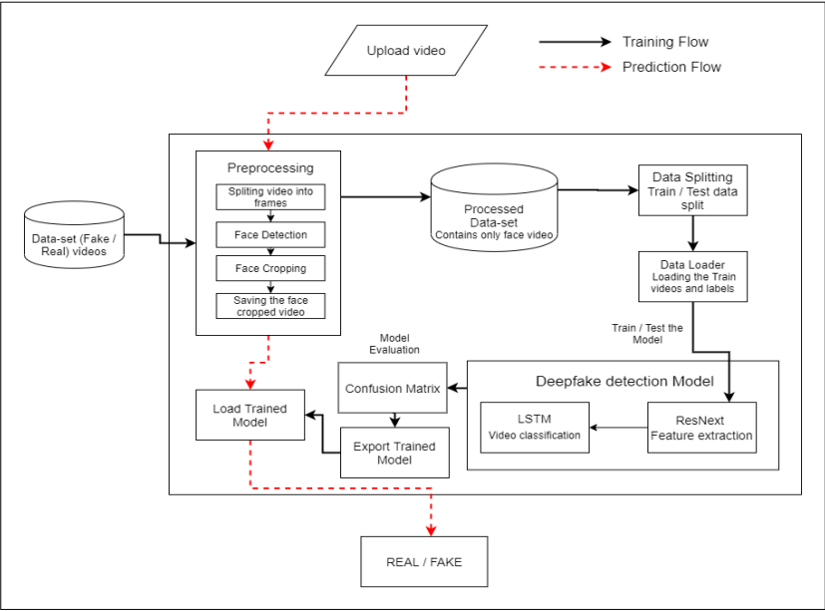

Technologies Used
- Frontend:
  - HTML, CSS: UI structure and styling.
  - JavaScript: Enhances interactivity.
- Backend:
  - Flask (Python): Handles server-side logic
  - File Upload APIs: Secure media file uploads.
- Databases:
  - Temporary Memory Management: Stores preprocessed data during analysis (no persistent storage mentioned).
- Recommendation Engine:
  - ResNet and LSTM: Analyzes video patterns.
  - Wav2Vec: Detects anomalies in audio.
  - Torch (PyTorch): Supports deep learning model training and inference.
- Frameworks & Libraries:
  - TensorFlow & Keras: These were used to build, train, and optimize the deep learning models. TensorFlow provided efficient computation, while Keras simplified model development.
  - OpenCV: Used for video processing, frame extraction, and face detection. It helped in preprocessing by isolating facial features before feeding them into the models.
  - Dlib: Primarily used for advanced face recognition and feature extraction. It allowed precise tracking of facial landmarks, helping in detecting distortions introduced by deepfake manipulations.
3.2 | Modules Description
1. Data-set Gathering
- Collected data from FaceForensic++ (FF), Deepfake Detection Challenge (DFDC), and Celeb-DF.
- Created a balanced dataset (50% real, 50% fake) with 600 videos (300 real, 300 fake).
- Removed audio-altered videos from DFDC for visual deepfake detection.
2. Pre-processing
- Videos split into frames, faces detected and cropped, then reassembled.
- 150-frame threshold set for computational efficiency.
- Processed videos stored at 30 fps, 112x112 resolution.
3. Data-set Split
- 70% (4,20 videos) for training, 30% (1,80 videos) for testing.
- Balanced distribution of real and fake videos in both sets.
4. Model Architecture
- ResNext CNN (resnext50_32x4d) extracts frame features.
- LSTM (2048 dimensions, 0.4 dropout) processes frames sequentially.
- Leaky ReLU activation, SoftMax for classification, batch size of 4.
5. Hyper-parameter Tuning
- Adam optimizer (learning rate 1e-5, weight decay 1e-3).
- Cross-entropy loss function, batch training with size 4.
6. User Interface (UI)
- Django-based UI for video upload and analysis.
- Displays prediction results with confidence score.
- Break down the system into functional modules.
- Describe the purpose and functionality of each module.
- Highlight the interactions between modules.

3.3 | Structural Diagrams
Class diagram
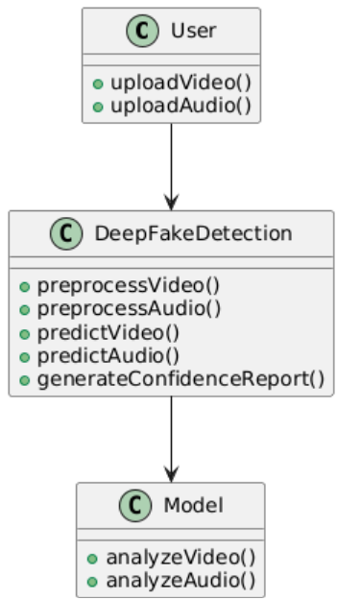
Component diagram
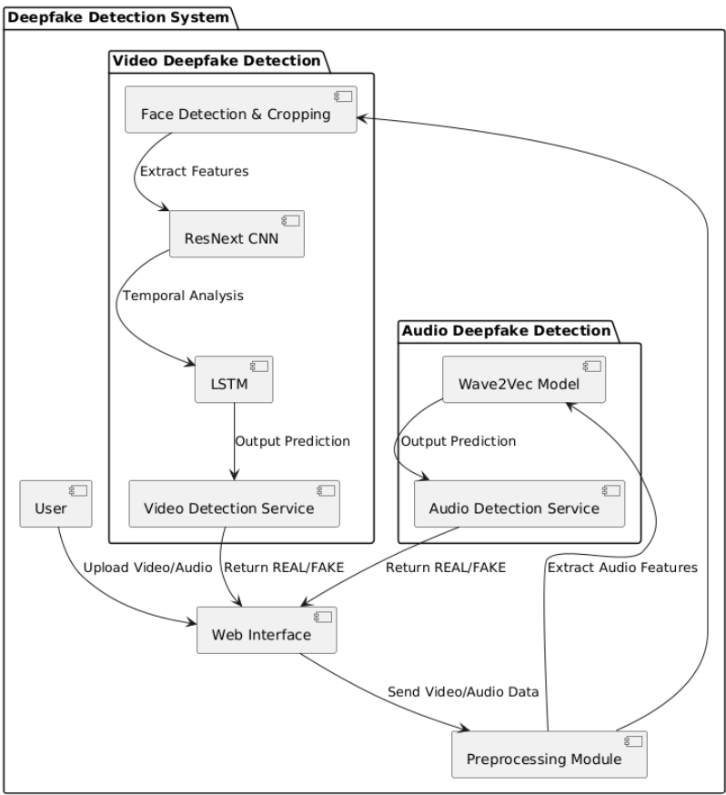
Deployement diagram
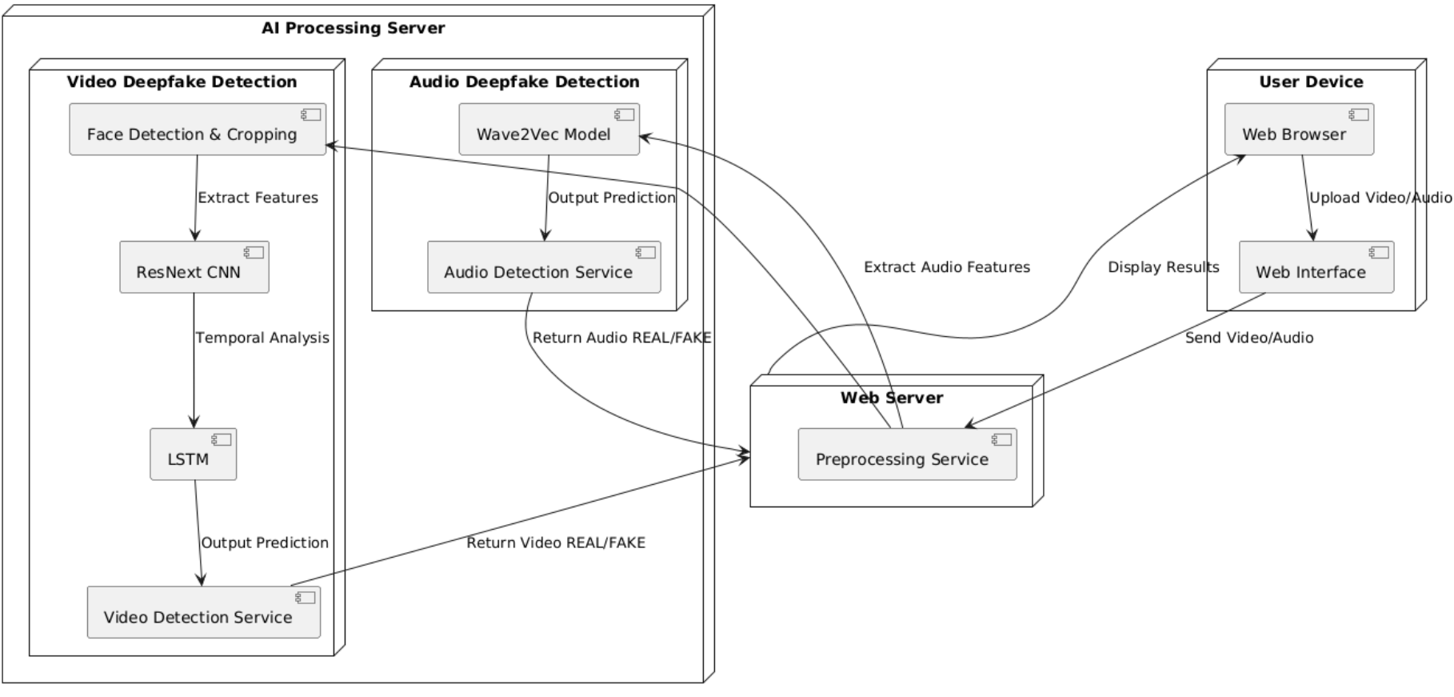

3.4 | Behavioural Diagrams
Activity diagram
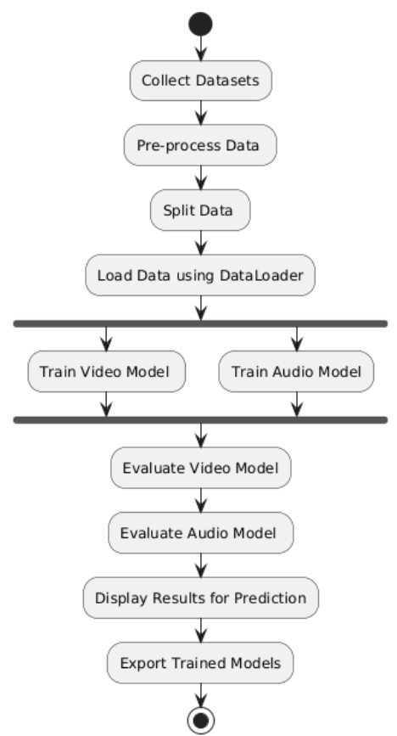
Sequence diagram
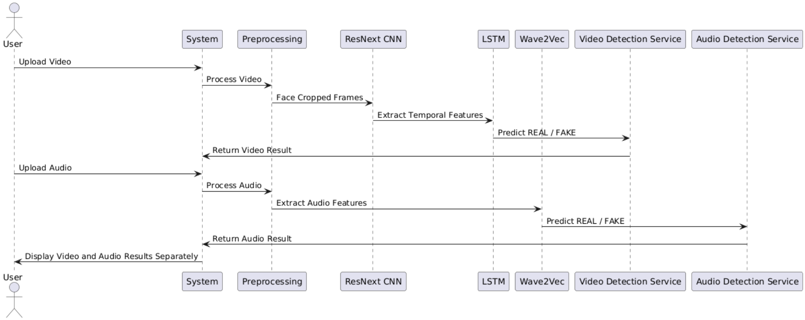
Use case diagram
